**Monte Sano Elementary School**

**Kindergarten Supply List**

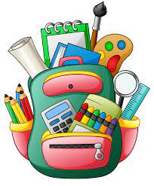

**Please have these items inside students backpack by the first week of school:**

* Full size backpack (no wheels or suitcases)
* 1 composition book (Primary ruled)
* 2 packs of yellow #2 pencils
* 2 packs of pencil top erasers
* 1 pack of dry erase markers
* 2 pairs of student safety scissors
* 2 boxes of 24 count Crayola crayons
* 2 Elmers glue sticks
* Headphones- over the head

**Teacher Wishlist:**

* 3 small pump bottles of hand sanitizer **OR** 1 large pump bottle of hand sanitizer
* 2 boxes of Kleenex

Thanks for your support😊